**Sequence Detector**

Sequence Detector using Finite Transducers

Finite Transducers are those machines which accepts input strings and convert them into a output strings.

Sequence Detector are the transducers which results in the output of 1 if the input sequence is detected or results in 0 if not

Let us assume that the given sequence is 10010.

There are two types of transducers namely

1)**moore machine**

2)**mealy machine**

**Moore Machine:**

The moore machine **M** is defined by a six tuple as

**M=(Q, Σ,Δ,** **δ,λ,q0)**

Where,

Q=finite set of states

Σ=finite set of input symbols

Δ =finite set of output symbols

δ =[Q X Σ ->Q]=state transition function

λ =[Q ->Δ ]=output function

q0=finite set of input states

To detect the sequence ‘10010’ we require a moore machine with definition as

**M=(Q, Σ,Δ,** **δ,λ,q0)**

With

Q=(q0,q1,q2,q3,q4,q5)

Σ=(0,1)

Δ=(0,1)

q0=q0

**Transiton Diagram:**

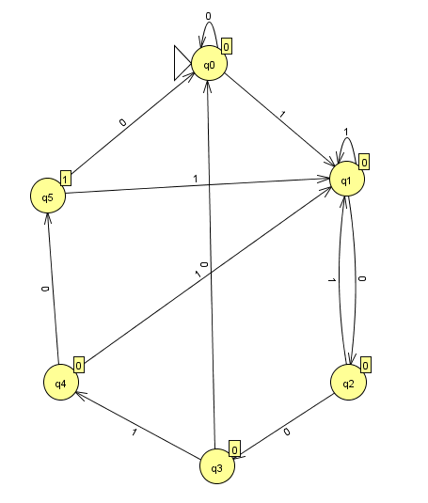

**5-bit sequence detector-10010-moore machine**

**Transition Table for moore machine:**

**present state next state output**

1. **1**

q0 q0 q1 0

q­1 q2 q1 0

q2 q3 q1 0

q3 q0 q4 0

q4 q5 q1 0

q5 q0 q1 1

**Mealy Machine:**

The moore machine **M** is defined by a six tuple as

**M=(Q, Σ,Δ,** **δ,λ,q0)**

Where,

Q=finite set of states

Σ=finite set of input symbols

Δ =finite set of output symbols

δ =state transition function

λ =[Q X Σ -> Δ] =output function

q0=finite set of input states

To detect the sequence ‘10010’ we require a moore machine with definition as

**M=(Q, Σ,Δ,** **δ,λ,q0)**

With

Q=(q0,q1,q2,q3,q4,q5)

Σ=(0,1)

Δ=(0,1)

q0=q0

**Transition diagram:**

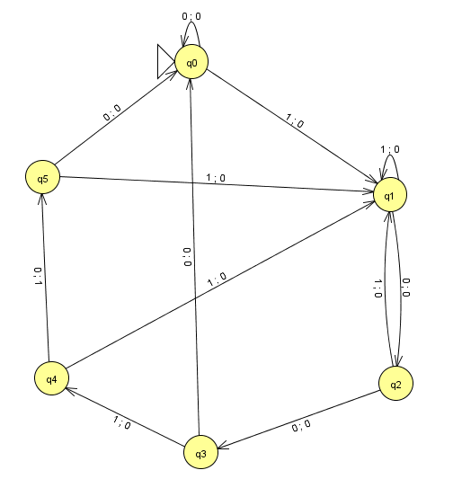

**5-bit sequence detector-10010**

**Transition table for mealy machine:**

**present state input output next state**

q0 0 0 q0

1 0 q1

q1 0 0 q2

1 0 q1

q2 0 0 q3

1 0 q1

q3 0 0 q0

1 0 q4

q4 0 1 q5

1 0 q2

q5 0 0 q0

1 0 q2